Java Paycheck GUI Lab Report
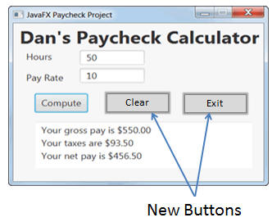
1) Enter your name, student ID, platform (Mac or PC) and date
Name and Student ID: Jibran Akhter - 1073973
Platform (Mac, PC, Linux, etc.): Windows 11 PC
Development System (NetBeans, Eclipse, etc.) Eclipse
Date: 5/6/2024

PROJECT DESCRIPTION:
Modify the Java Paycheck GUI program to add two new buttons, Clear and Exit and their event handlers.
When Clear is clicked: a) clear the user's input for Hours, b) clear the user's input for Pay Rate, and
c) clear the program output that shows the pay and taxes. End the program when Exit is clicked.

Choose to modify either the JavaFX or Swing version of the program.The source code for the Java Paycheck GUI project is available for download from the class website or:
a) JavaFX version
http://program-info.net/Java/downloads/JavaPaycheckGUI/JavaFXPaycheck.java
b) Java Swing version
http://program-info.net/Java/downloads/JavaPaycheckGUI/JavaPaycheckSwing.java

LAB REPORT:
2) Fill in the INPUT/PROCESSING/OUTPUT table (HIPO chart). Use either English or pseudo-code in the PROCESSING column. Do not paste code from your Visual Basic program.
INPUT | PROCESSING | OUTPUT
Hours (from txtHours) | 1. Read Inputs: Read numeric values from txtHours and txtPayRate.  2. Validate Inputs: Check if the inputs are non-negative numbers; if not, display an error message. | Gross Pay, Taxes, and Net Pay displayed in txtPaycheck.
Pay Rate (from txtPayRate) | 3. Calculate Pay: If Hours <= 40: regHours = Hours overtimeHours = 0< Else: regHours = 40 overtimeHours = Hours – 40  4. Compute Payments: regPay = regHours * Pay Rate overtimePay = overtimeHours * Pay Rate * OVERTIME_RATE grossPay = regPay + overtimePay  5. Calculate Taxes and Net Pay: taxes = grossPay * TAX_RATE netPay = grossPay - taxes | Display formatted results in txtPaycheck: - Gross Pay - Taxes - Net Pay
Compute button click | 6. Display Results: Format the grossPay, taxes, and netPay to two decimal places and display in txtPaycheck. | Updates txtPaycheck with the computed results.
Clear button click | 7. Clear Inputs and Outputs: Clear the text fields (txtHours, txtPayRate) and the text area (txtPaycheck). | Clears inputs and outputs in the UI.
Exit button click | 8. Exit Application: Terminate the application process. | Closes the application window.

3) Fill in the TEST VALUES & RESULTS table
Show at different possibilities of valid and invalid inputs. Use a calculator to compute the expected values for valid inputs. The actual values are to be what the program displayed.
Hours | PayRate | EXPECTED RESULTS | ACTUAL RESULTS
35 hours | $20.00/hr | Grosspay: $700  Taxes: $119  Net pay: $581 | Your gross pay is $700.00  Your taxes are $119.00  Your net pay is $581.00
40 hours | $50.00/hr | Grosspay: $2000  Taxes: $340  Net pay: $1680 | Your gross pay is $2000.00  Your taxes are $340.00  Your net pay is $1680.00
50 hours | $35.50/hr | Grosspay: $1925  Taxes: $327.25  Net pay: $1597.75 | Your gross pay is $1925.00  Your taxes are $327.25  Your net pay is $1597.75
Forty (entered as letters) | $5.00/hr | Please try again | Values for hours and payrate must be numeric
Negative value for pay rate | -20.00/hr | Please try again | Inputs must be positive.
Pay Rate Missing |  | Please try again | Values for hours and payrate must be numeric
The Clear button is clicked |  | Clears all text boxes | Clears all text boxes
The Exit button is clicked |  | Exits from the program | Exits from the program

DISCUSSION:
4) Complete the DISCUSSION section in English. It does not need to be long, but it needs to be complete.
4a) What did you do to develop the program?
To develop the JavaFX Paycheck application, I started by understanding the requirements, which included inputting hours and pay rates, calculating pay including overtime, and managing taxes, along with the necessary UI controls for interaction. Most of the user interface was designed by the professor using JavaFX, which included text fields for input, a text area for output, and buttons for operations like compute, clear, and exit.

4b) What problems did you have and how did you overcome the problems?
Initially, I thought the application would crash if non-numeric inputs were entered because it expected numbers for calculations. SO it seems the professor added exception handling for `NumberFormatException` to catch errors when parsing non-numeric strings to doubles. This ensures the application remains stable and informs the user about the input error.

4c) Where in the program is the processing for illegal inputs, such as letters instead of numbers being entered for hours or pay rate?
The processing for illegal inputs is handled within the `btnComputeClick` method.

PROGRAM OUTPUT:
5) Show screenshots showing correct operation of the program. Refer to previous lab assignments to review how to save a screen shot to the lab report. Adjust the size of the image on the report to show the summary information and the image of the paycheck.

50 hours at $35.00/hr | The letters "Forty" entered for hours
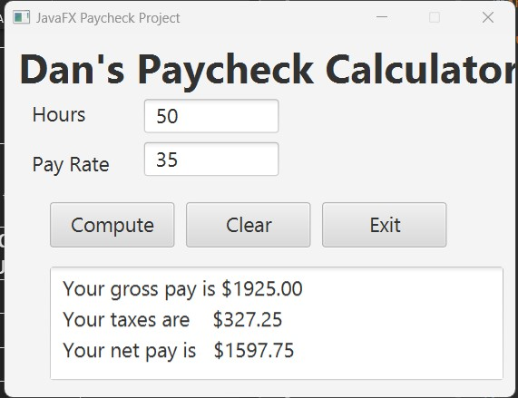 | 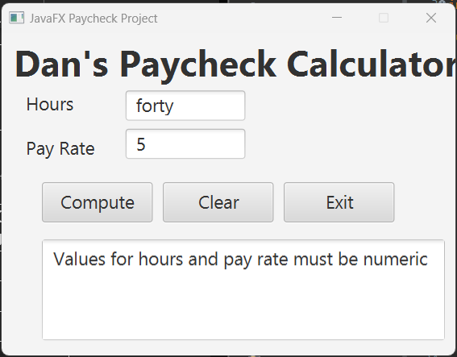
Pay Rate Missing | The Clear button clicked
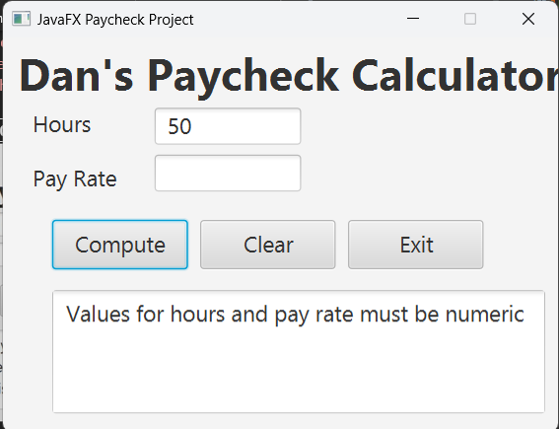

PROGRAM LISTING:
6) Copy and paste the code for the entire program.
package application;

import javafx.application.Application;
import javafx.stage.Stage;
import javafx.scene.Scene;
import javafx.scene.control.TextField;
import javafx.scene.control.TextArea;
import javafx.scene.control.Button;
import javafx.scene.control.Label;
import javafx.scene.text.Font;
import javafx.scene.layout.Pane;
import javafx.scene.text.FontWeight;

public class JavaFXPaycheck extends Application {
// Define constants
public static final double OVERTIME_RATE = 1.5;
public static final double TAX_RATE = 0.17;

// UI Controls
private static TextField txtHours, txtPayRate;
private static TextArea txtPaycheck;

@Override
public void start(Stage stage) {
Pane root = new Pane();
createControls(root);

Scene scene = new Scene(root, 450, 320);
stage.setTitle("JavaFX Paycheck Project");
stage.setResizable(false);
stage.setScene(scene);
stage.show();
}

public static void main(String[] args) {
launch(args);
}

private static void btnComputeClick() {
double hours;
double payRate;
double regHours, overtimeHours;
double regPay, overtimePay;
double grossPay, taxes, netPay;

try {
hours = Double.valueOf(txtHours.getText());
payRate = Double.valueOf(txtPayRate.getText());
if (hours < 0 || payRate < 0)
throw new IllegalArgumentException("Inputs must be positive");
} catch (NumberFormatException e) {
txtPaycheck.setText("Values for hours and pay rate must be numeric");
return;
} catch (IllegalArgumentException e) {
txtPaycheck.setText(e.getMessage());
return;
}

if (hours <= 40) {
regHours = hours;
overtimeHours = 0.0;
} else {
regHours = 40.0;
overtimeHours = hours - 40.0;
}

regPay = regHours * payRate;
overtimePay = overtimeHours * payRate * OVERTIME_RATE;
grossPay = regPay + overtimePay;
taxes = grossPay * TAX_RATE;
netPay = grossPay - taxes;

txtPaycheck.setText(
String.format("Your gross pay is $%.2f\n", grossPay) +
String.format("Your taxes are $%.2f\n", taxes) +
String.format("Your net pay is $%.2f", netPay));
}

private static void btnClearClick() {
txtHours.clear();
txtPayRate.clear();
txtPaycheck.clear();
}

private static void createControls(Pane root) {
Font font36B = Font.font("Ariel", FontWeight.BOLD, 36);
Font font18 = Font.font("Ariel", FontWeight.NORMAL, 18);

Label lblTitle = new Label("Dan's Paycheck Calculator");
lblTitle.setFont(font36B);
lblTitle.setLayoutX(12);
lblTitle.setLayoutY(4);
root.getChildren().add(lblTitle);

Label lblHours = new Label("Hours");
lblHours.setFont(font18);
lblHours.setLayoutX(24);
lblHours.setLayoutY(57);
root.getChildren().add(lblHours);

txtHours = new TextField();
txtHours.setFont(font18);
txtHours.setLayoutX(123);
txtHours.setLayoutY(57);
txtHours.setMaxSize(119,30);
txtHours.setMinSize(119,30);
root.getChildren().add(txtHours);

Label lblPayRate = new Label("Pay Rate");
lblPayRate.setFont(font18);
lblPayRate.setLayoutX(24);
lblPayRate.setLayoutY(101);
root.getChildren().add(lblPayRate);

txtPayRate = new TextField();
txtPayRate.setFont(font18);
txtPayRate.setLayoutX(123);
txtPayRate.setLayoutY(95);
txtPayRate.setMaxSize(119,30);
txtPayRate.setMinSize(119,30);
root.getChildren().add(txtPayRate);

Button btnCompute = new Button("Compute");
btnCompute.setFont(font18);
btnCompute.setLayoutX(40);
btnCompute.setLayoutY(148);
btnCompute.setMaxSize(110,40);
btnCompute.setMinSize(110,40);
btnCompute.setOnAction(e -> btnComputeClick());
root.getChildren().add(btnCompute);

Button btnClear = new Button("Clear");
btnClear.setFont(font18);
btnClear.setLayoutX(160);
btnClear.setLayoutY(148);
btnClear.setMaxSize(110,40);
btnClear.setMinSize(110,40);
btnClear.setOnAction(e -> btnClearClick());
root.getChildren().add(btnClear);

Button btnExit = new Button("Exit");
btnExit.setFont(font18);
btnExit.setLayoutX(280);
btnExit.setLayoutY(148);
btnExit.setMaxSize(110,40);
btnExit.setMinSize(110,40);
btnExit.setOnAction(e -> System.exit(0));
root.getChildren().add(btnExit);

txtPaycheck = new TextArea();
txtPaycheck.setFont(font18);
txtPaycheck.setLayoutX(40);
txtPaycheck.setLayoutY(205);
txtPaycheck.setMinSize(400,100);
txtPaycheck.setMaxSize(400,100);
txtPaycheck.setEditable(false);
root.getChildren().add(txtPaycheck);
}
}

